Table of Contents

Server Started Successfully 2

Client Started Successfully 3

JSON Page displayed Successfully 4

Expense Tracker Screen 5

Addition of New Expense Screen 6

Added Expense is added 7

## Server Started Successfully

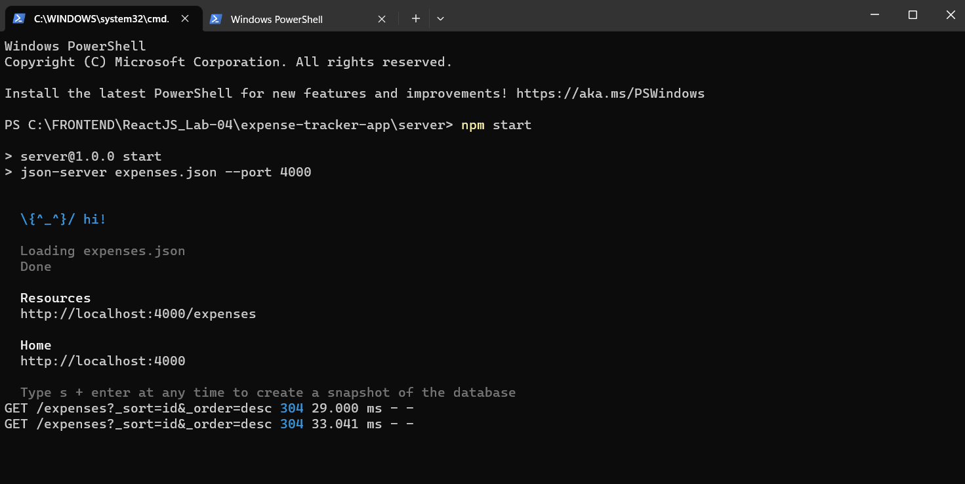

## Client Started Successfully

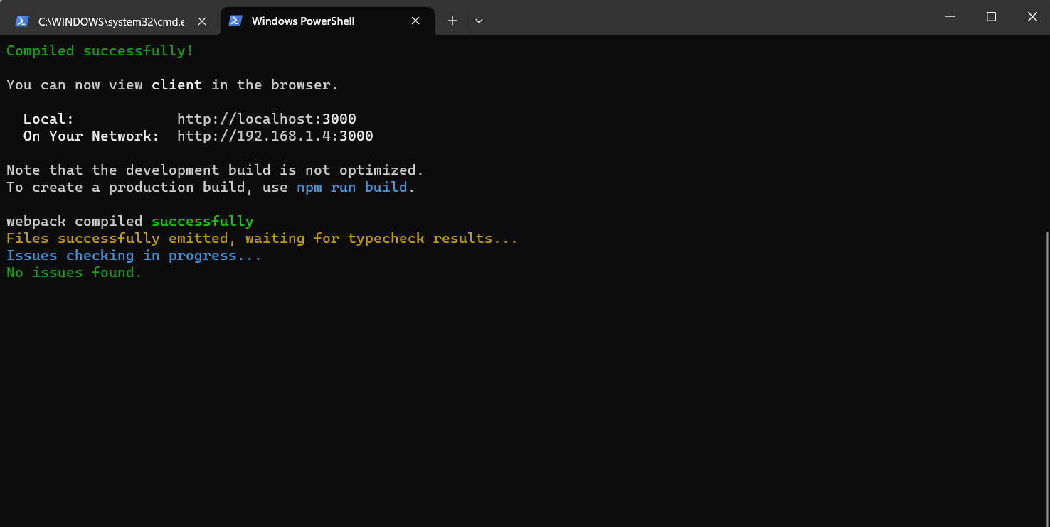

## JSON Page displayed Successfully

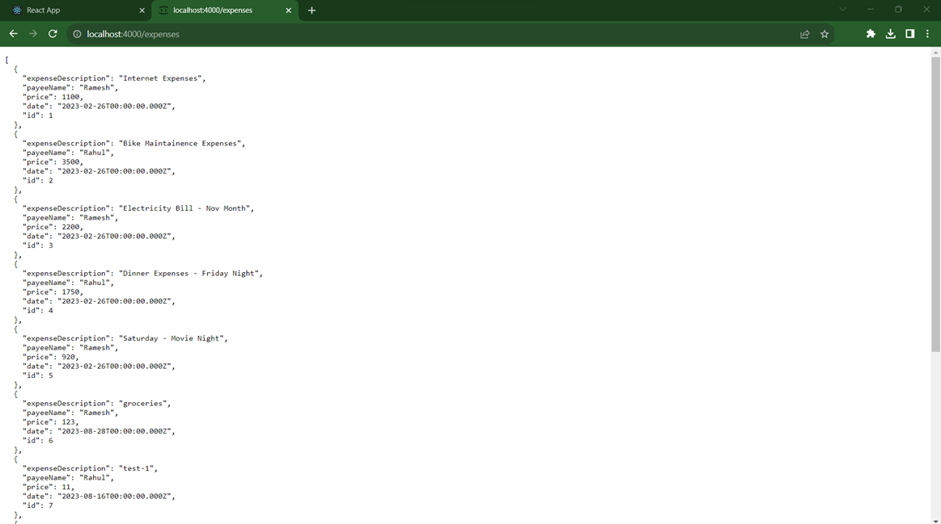

## Expense Tracker Screen

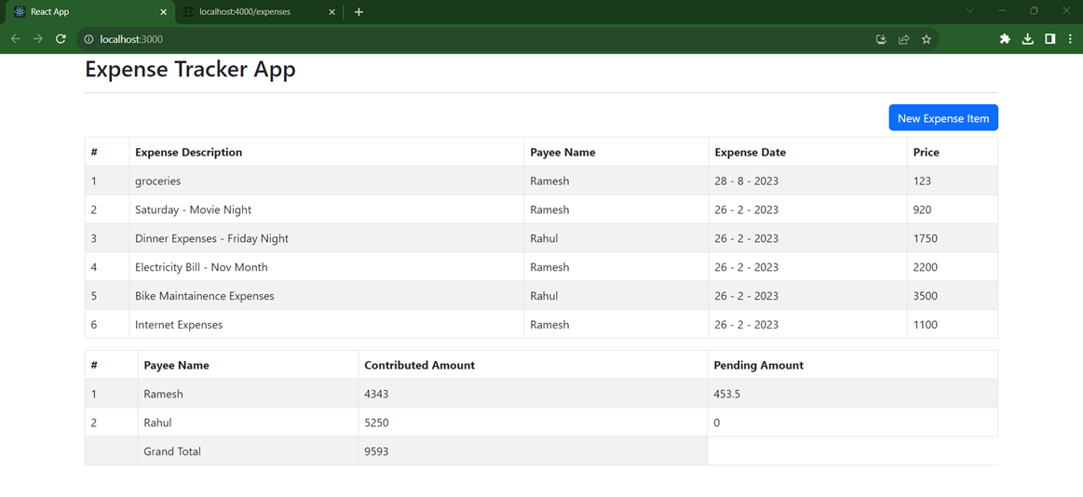

## Addition of New Expense Screen

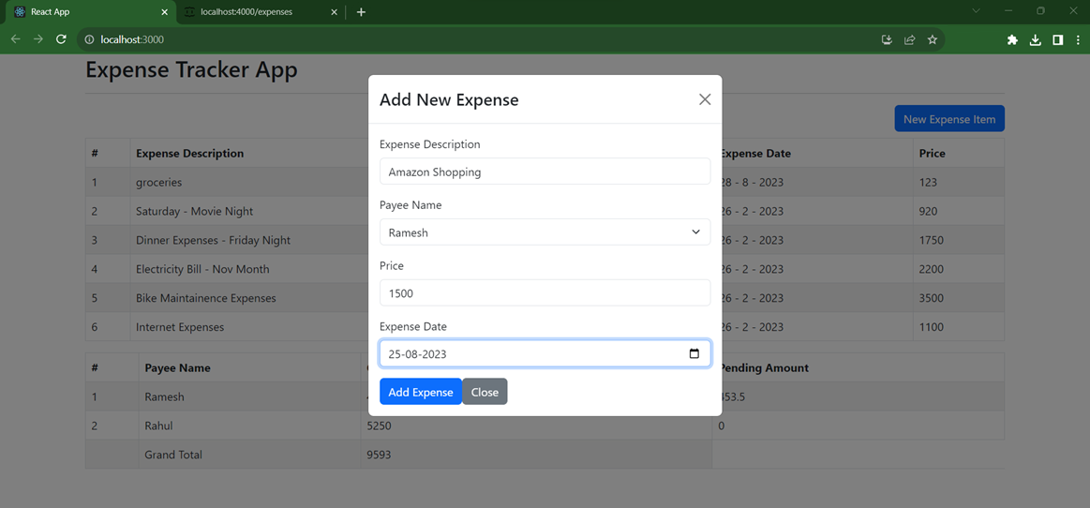

## Added Expense is added

